*Project: Teaching Allocation System (TAS)*

**Project Planning Document**

Table of Contents

1. Scope 3

1.1 Aims of the project 3

1.2 The rationale 3

1.3 The feasibility 3

1.4 System context 3

1.5 Inclusions 3

1.6 Exclusions 4

1.7 Limitations 4

2. Describe Characteristics of the Project and Development Model 4

2.1 Characteristics of the Project 4

2.2 Development Process Model 4

2.3 Justification of the Model Selection 5

3. Estimation of Size 5

3.1 Decomposition of the System 5

3.2 Function Point (FP) Analysis 7

3.2.1 User Interface 7

3.2.2 Administrator Interface 10

3.3 Size Estimation 15

4. Cost Estimate 15

4.1 Staff Salaries 15

4.2 Equipment Rental 15

4.3 Software Purchases 15

4.4 Consultation Fees 15

4.5 Overheads 15

5. Planning and Scheduling 16

5.1 Task List 16

5.2 Task Network 17

5.3 Schedule (Gantt chart) 17

5.4 Minimum Time Estimated (From task graph) 18

5.5 Human Resources 19

5.5.1 Team Structure 19

5.5.2 Additional Member Responsibilities 19

5.6 Estimate of Effort (*Person-Months*) 19

# 1. Scope

## 1.1 Aims of the project

Teaching Allocation System is a software which is used to automatic allocate units for academic staff members according to their information, moreover, this system should be managed by an educational institute.

## 1.2 The rationale

* Time will be saved if the system can be completed because it can allocate units for academic staff members automatically or semi-automatically.
* There will be less conflict when the units should be allocated.
* Problems which need to be tackled by people will be less, which will reduce human resource.
* It is easy to management because report of the allocation statistics will be generated.

## 1.3 The feasibility

The project can be done in consideration of four areas, including cost, time, personnel and technology. Related details will be shown in this document.

## 1.4 System context

This teaching allocation system should be performed on a single central server and multiple academic staff will use the system by connecting with the central server, therefore, connection will be an important issue for implementation. In addition, this system will be popularized to various institute so that some issues will appear about the future support.

## 1.5 Inclusions

* Create a database to record the information and preference of academic staff members.
* Create an interface for both academic staff and administrators to login.
* Online teaching preference submission.
* Centralized operations (teaching allocation operations are performed on a single central server).
* Automatic or semi-automatic teaching allocation.
* Online teaching allocation adjustment and confirmation.
* Report generation.
* Automatic retrieval and publication of statistics from managed resources.
* Perform system backup and restore.

## 1.6 Exclusions

* Create a database to record the students’ information.
* Store the personal information which is not related to teaching allocation.
* Allocate staff member over their teaching load limitation (over 4 units).
* Functions which are not for the teaching allocation purpose.
* Allow academic staff to modify the units’ attributes.

## 1.7 Limitations

* The system is to be run on the Internet/Intranet in a centralized manner, but the initial demonstration of the application may be on a standalone or isolated system.
* The system operations must conform to the teaching allocation policies set up by the institute.

# 2. Describe Characteristics of the Project and Development Model

## 2.1 Characteristics of the Project

* The requirements of the project has well defined, which have been described in details in operational concept document and analysed by team members. In addition, requirements will not be changed a lot during the development of system.
* The planner, designer and developer are all students who are familiar with the allocation system, so some risks can be reduced.
* This project is a short project because the duration of project is less than three months and it is enough to complete.
* The scope of this project has been identified well by team members so that it is very clear to develop this system.
* The work flow of this project is in reasonably linear fashion.

## 2.2 Development Process Model

Because of the characteristics of the project, we use **Waterfall** process model.

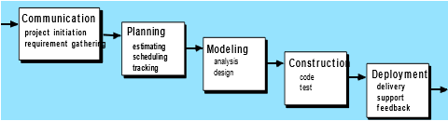

## 2.3 Justification of the Model Selection

Here are the reasons and advantages of using waterfall as the process model for this project.

Reasons and advantages:

* It is easy to control the process of the project.
* It is easy to arrange tasks.
* Milestones can be defined clearly.
* Each phase can be completed at a time.
* Process and results are well documented.

# 3. Estimation of Size

## 3.1 Decomposition of the System

**User Interface:**

* Login/Register accounts
* Home page
* Result/confirmation page (+contact hours, number of lectures/pracs)
* Select/change/search teaching preferences

**Administrator Interface:**

* Administrator home page
* Accounts management (Administrator, Set up/manage accounts, Suspend/terminate accounts)
* Units management (Add/remove teaching units)
* Teaching allocation management (Modify/adjust/verify allocation, generate reports)
* Allocation statistics generation (Automatic retrieval and publication)

**Data Model:**

A data model is to manage relationships between the data

* Academic staff members should use numbers (1, 2, 3 and 4) to represent their preference and different numbers stand for different level of preference.
  + 1 indicates the most preferred unit
  + 2 indicates the staff would like to teach a unit
  + 3 indicates the staff can but does not like to teach a unit
  + 4 indicates the staff is unable to teach a unit
* Each staff can only be allocated 4 units at most (units/staff<4)
* There are also import rules should be obeyed when allocating units for staff automatically
* If there is one staff who indicates 1 for a unit, the unit should be allocated to this staff and the limitation rule should be obeyed

(Staff $\underset{→}{preference is 1}$ unit & units/staff<4)

* + If there are two or more staff who indicate 1 for a unit, the one who is teaching currently should be allocated to this unit and the limitation rule should be obeyed

(Staff $\underset{→}{teaching currently \& preference is 1}$ unit & units/staff<4)

* + If there are two or more staff who indicate 1 for a unit but there is no one who is teaching currently, the one who has taught this unit before will be allocated to and limitation rule should be obeyed

(Staff $\underset{→}{has taught \& preference is 1}$ unit & units/staff<4)

* + If there are two or more staff who indicate 1 for a unit but there is no one who is teaching currently and no one has taught before, the one who has the least allocated units will be allocated to and limitation rule should be obeyed

(Staff $\underset{→}{has the least allocated units \& preference is 1}$ unit & units/staff<4)

* + If there are two or more staff who indicate 1 for a unit but there is no one who is teaching currently, no one has taught before and their numbers of allocated units are the same, system will random choose one and limitation rule should be obeyed

(Staff $\underset{→}{random \& preference is 1}$ unit & units/staff<4)

* + If there is no one who indicates 1 for a unit, staff who indicate 2 or 3 should be considered and as above rules as well, limitation rule should also be obeyed

(Staff $\underset{→}{preference is 2 or 3}$ unit & units/staff<4)

* + If staff indicate 4 for a unit, this unit cannot be allocated to this staff

(Staff $\underset{→}{preference is 4}$ unit)

* + If all staff indicate 4 for a unit, teaching administrator should contact with staff and modify
* Each unit must has a unit chair and a lecturer (unit chair=1 & lecturer=1, unit chair can be the unit lecturer) and here are the rules for allocation:
  + Casual or new staff cannot be unit lecturer (staff $\underset{→}{not casual or new}$ unit lecturer)
  + If there is no one who indicates 1, 2 or 3 for the units, the unit lecturer will become the unit chair (unit lecturer $\underset{→}{no one 1, 2 or 3}$ unit chair)
* Database should be created to record data.

**Storage:**

* Accounts Database
* Teaching Allocation Information Database

## 3.2 Function Point (FP) Analysis

As a consequence of the decomposition of the system, we use Function Point (FP) analysis to estimate the size of this project. The following two parts of analysis are the estimating process.

### 3.2.1 User Interface

User Interface is for academic staff to use.

User interfaces can be divided into several parts, including login, register, select/change/search teaching preferences, home, and result/confirmation page.

1. **Home Page**

There are six external inputs, including login, register, select preference, search for result, login out and help.

|  |  |  |  |
| --- | --- | --- | --- |
| EI | FTR | DET | UFP |
| Login | 1 | 1 | 3 |
| Register | 1 | 1 | 3 |
| Select Preference | 2 | 2 | 3 |
| Search for Result | 2 | 6 | 4 |
| Login out | 1 | 1 | 3 |
| Help | 1 | 1 | 3 |
| **Total=19** | | | |

1. **Login**

There is an internal logical file which is staff accounts for the system, and no external interface file. The content of the file is shown below.

|  |  |
| --- | --- |
| Staff Account | |
| Username | Password |
|  |  |

|  |  |  |  |
| --- | --- | --- | --- |
| ILF | RET | DET | UFP |
| Staff Account | 1 | 2 | 7 |

|  |  |  |  |
| --- | --- | --- | --- |
| EI | FTR | DET | UFP |
| Username | 1 | 1 | 3 |
| Password | 1 | 1 | 3 |
| **Total=6** | | | |

1. **Register**

There is one internal logical file which is staff accounts allocation, and one external interface file which is staff information provided by related department. The content of each file are shown below.

|  |  |  |
| --- | --- | --- |
| Staff Accounts Allocation | | |
| Staff ID | Username | Password |
|  |  |  |

|  |  |  |  |  |  |
| --- | --- | --- | --- | --- | --- |
| Staff Information | | | | | |
| ID | First Name | Last Name | Sex(F/M) | Email | Phone |
|  |  |  |  |  |  |

|  |  |  |  |
| --- | --- | --- | --- |
| ILF | RET | DET | UFP |
| Staff Accounts Allocation | 1 | 3 | 7 |

|  |  |  |  |
| --- | --- | --- | --- |
| EIF | RET | DET | UFP |
| Staff Information | 1 | 6 | 5 |

|  |  |  |  |
| --- | --- | --- | --- |
| EI | FTR | DET | UFP |
| Staff ID | 1 | 1 | 3 |
| Username | 1 | 1 | 3 |
| Password | 1 | 1 | 3 |
| **Total=9** | | | |

1. **Select/change/search teaching preferences**

There is one internal logical file which is staff preference sheet, and one external interface file which is information of courses, which should be provided by related department. The contents of each file are shown below.

|  |  |  |  |
| --- | --- | --- | --- |
| Course Information | | | |
| ID | Title | Trimester | Credit Point |
|  |  |  |  |

|  |  |
| --- | --- |
| Preference Sheet | |
| Preference | Comment |
|  |  |

**Therefore, there are results**

|  |  |  |  |
| --- | --- | --- | --- |
| **ILF** | **RET** | **DET** | **UFP** |
| Preference Sheet | 2 | 2 | 7 |

|  |  |  |  |
| --- | --- | --- | --- |
| **EIF** | **RET** | **DET** | **UFP** |
| Course Information | 1 | 2 | 5 |

|  |  |  |  |
| --- | --- | --- | --- |
| **EI** | **FTR** | **DET** | **UFP** |
| Select Preference | 2 | 2 | 3 |
| Change Preference | 2 | 2 | 3 |
| **Total=6** | | | |

|  |  |  |  |
| --- | --- | --- | --- |
| **EQ** | **FTR** | **DET** | **UFP** |
| Search Preference | 2 | 6 | 4 |

**System complexity factors**

|  |  |
| --- | --- |
| **GSC** | **Value(0-5)** |
| Data communication | 4 |
| Distributed data processing | 4 |
| Performance | 0 |
| Heavily used configuration | 0 |
| Transaction rate | 1 |
| On-Line data entry | 5 |
| End-user efficiency | 2 |
| On-Line update | 3 |
| Complex processing | 0 |
| Reusability | 3 |
| Installation ease | 0 |
| Operational ease | 0 |
| Multiple sites | 0 |
| Facilitate change | 1 |
| **Total** | 23 |
| **VAF=0.65+(23/100)=0.88** | |

The calculation of unadjusted function point is 75 so that

Function point = 0.88*75 = 66

### 3.2.2 Administrator Interface

Administrator interface is for teaching administrator, system administrator and head of the institute.

Administrator interface can be divided into five parts, including account management, unit management, teaching allocation management, allocation statistics generation, and administrator home page.

1. **Admin Home Page**

There is 3 external inputs, including account EI, unit EI, and teaching allocation EI.

|  |  |  |  |
| --- | --- | --- | --- |
| **Account EI** | **FTR** | **DET** | **UFP** |
| Login, Register, Account management | 1 | 3 | 3 |
| Unit EI | FTR | DET | UFP |
| Teaching unit management | 1 | 1 | 3 |
| Teaching allocation EI | FTR | DET | UFP |
| Teaching allocation management, Allocation statistics generation | 1 | 2 | 3 |
| **Total UFPs = 9** | | | |

There is no ILFs, EIFs, EOs or EQs.

1. **Account Management**

There is an internal logical file which is staff account information, and no external interface file. The content of the file is shown below (Login and Register can be solved by the user interfaces case).

|  |  |  |  |  |  |
| --- | --- | --- | --- | --- | --- |
| Staff Account Management | | | | | |
| ID | Username | ADD | Suspend | Terminate | Update |
|  |  |  |  |  |  |

|  |  |  |  |  |  |
| --- | --- | --- | --- | --- | --- |
| Staff Account Information | | | | | |
| Username | Password | ID | Sex | First Name | Last Name |
|  |  |  |  |  |  |
| Phone Num | Email |  |  |  |  |
|  |  |  |  |  |  |

|  |  |  |  |
| --- | --- | --- | --- |
| ILF | RET | DET | UFP |
| Account Management | 1 | 5 | 7 |

|  |  |  |  |
| --- | --- | --- | --- |
| EIF | RET | DET | UFP |
| Staff Account | 1 | 8 | 5 |

|  |  |  |  |
| --- | --- | --- | --- |
| EI | FTR | DET | UFP |
| Staff Account Management | 1 | 10 | 3 |
| **Total UFPs = 15** | | | |

1. **Unit Management**

There is an internal logical file, which is unit management, and an external interface file, which is the unit information provided by related department. The content of each file are shown below.

|  |  |  |  |  |  |
| --- | --- | --- | --- | --- | --- |
| Teaching Unit Management | | | | | |
| Unit ID | Unit Title | ADD | REMOVE | EDIT | Update |
|  |  |  |  |  |  |

|  |  |  |  |  |  |
| --- | --- | --- | --- | --- | --- |
| Unit Information | | | | | |
| ID | Unit Title | Contact Hours | Unit Chair | Num of Pracs | Num of Lectures |
|  |  |  |  |  |  |
| Trimester | Credit Point | Maximum Lecturers | Unit Lecturer |  |  |
|  |  |  |  |  |  |

|  |  |  |  |
| --- | --- | --- | --- |
| ILF | RET | DET | UFP |
| Teaching Unit Management | 1 | 5 | 7 |

|  |  |  |  |
| --- | --- | --- | --- |
| EIF | RET | DET | UFP |
| Unit Information | 0 | 10 | 5 |

|  |  |  |  |
| --- | --- | --- | --- |
| EI | FTR | DET | UFP |
| Teaching Unit Management | 1 | 5 | 3 |
| **Total UFPs = 15** | | | |

1. **Teaching Allocation Management**

There are two internal logical files, which are Allocation Management and Results Modification, and two external interface files, which are Available Staff List, and Staff Preferences Sheet. The contents of each file are shown below.

|  |  |  |  |  |  |
| --- | --- | --- | --- | --- | --- |
| Allocation Management | | | | | |
| Unit ID | Unit title | Unit Chair | Unit Lecturer | Preference collection start | Preference collection end |
|  |  |  |  |  |  |
| Allocate | Modify results | Verify allocation finished | Send results via e-mail | Verify allocation confirmed | Generate allocation reports |
|  |  |  |  |  |  |

|  |  |  |  |
| --- | --- | --- | --- |
| Results Modification | | | |
| Unit ID | Unit Title | Unit Chair | Unit Lecturer |
|  |  |  |  |
| Available staff list (by unit) | Add Unit Chair | Add Unit Lecturer | Remove Unit Chair |
|  |  |  |  |
| Remove Unit Lecturer | Update |  |  |
|  |  |  |  |

|  |  |  |  |
| --- | --- | --- | --- |
| Available Staff List | | | |
| Staff Name | Units allocated | Preference | Comment |
|  |  |  |  |

|  |  |  |  |
| --- | --- | --- | --- |
| Staff Preferences Sheet | | | |
| Account ID | Unit ID | Preference | Comment |
|  |  |  |  |

Therefore, the results are:

|  |  |  |  |
| --- | --- | --- | --- |
| ILF | RET | DET | UFP |
| Allocation Management | 5 | 11 | 7 |
| Results Modification | 4 | 8 | 7 |

|  |  |  |  |
| --- | --- | --- | --- |
| EIF | RET | DET | UFP |
| Available Staff List | 1 | 4 | 5 |
| Preferences Sheet | 1 | 4 | 5 |

|  |  |  |  |
| --- | --- | --- | --- |
| EI | FTR | DET | UFP |
| Allocation Management | 2 | 12 | 4 |
| Results Modification | 2 | 9 | 4 |

|  |  |  |  |
| --- | --- | --- | --- |
| EQ | FTR | DET | UFP |
| Allocation | 2 | 6 | 4 |

|  |  |  |  |
| --- | --- | --- | --- |
| EO | FTR | DET | UFP |
| Generation | 1 | 6 | 4 |

|  |
| --- |
| **Total UFPs = 40** |

1. **Allocation Statistics Generation**

There are two external interface files, which are Staff Preferences Sheet and Allocation Report Sheet. The contents of each file are shown below.

|  |  |
| --- | --- |
| Allocation Statistics Generation | |
| Preference Statistics Generation | Unit Allocation Statistics Generation |
|  |  |

|  |  |  |  |
| --- | --- | --- | --- |
| Staff Preferences Sheet | | | |
| Account ID | Unit ID | Preference | Comment |
|  |  |  |  |

|  |  |  |  |
| --- | --- | --- | --- |
| Allocation Report Sheet | | | |
| Unit ID | Unit Title | Unit Chair | Unit Lecturer |
|  |  |  |  |
| Trimester | Credit Points |  |  |
|  |  |  |  |

|  |  |  |  |
| --- | --- | --- | --- |
| EIF | RET | DET | UFP |
| Preferences Sheet | 1 | 4 | 5 |
| Report Sheet | 1 | 6 | 5 |

|  |  |  |  |
| --- | --- | --- | --- |
| EI | FTR | DET | UFP |
| Statistics Generation | 1 | 1 | 3 |

|  |  |  |  |
| --- | --- | --- | --- |
| EO | FTR | DET | UFP |
| Generation | 2 | 9 | 5 |
| **Total UFPs = 18** | | | |

**System complexity factors:**

|  |  |
| --- | --- |
| **GSC** | **Value(0-5)** |
| Data communication | 4 |
| Distributed data processing | 4 |
| Performance | 0 |
| Heavily used configuration | 0 |
| Transaction rate | 1 |
| On-Line data entry | 2 |
| End-user efficiency | 2 |
| On-Line update | 3 |
| Complex processing | 1 |
| Reusability | 3 |
| Installation ease | 0 |
| Operational ease | 0 |
| Multiple sites | 0 |
| Facilitate change | 1 |
| **Total GSC factors** | **21** |
| **VAF = 0.65+(21/100) = 0.86** | |

**Total UFPs:**

|  |  |
| --- | --- |
| **Unadjusted Function Points** (UFPs) | |
| **Section Name** | **UFPs Counted** |
| Home Page | 9 |
| Account Management | 15 |
| Unit Management | 15 |
| Teaching Allocation Management | 40 |
| Allocation Statistics Generation | 18 |
| **Total UFPs** | **97** |

Total UPFs is 97, and VAF is 0.86, so

Adjusted Function Point = 0.86*97 = 83.42 = rounded to **83** FP.

## 3.3 Size Estimation

* As the consequence of the above two function points estimation, total adjusted function points is 66 + 83 = 149 FP

# 4. Cost Estimate

## 4.1 Staff Salaries

* Developers can write 200 LOC per person per month and salary is $50 per hour per person
* Developers work eight hours per day, 30 days per month

|  |  |  |  |  |  |
| --- | --- | --- | --- | --- | --- |
| Staff | Number | LOC | Duration  Month(h) | Salary per hour | Calculation |
| Database developer | 1 | 400 | 2(480) | $50 | $24000 |
| Software developer | 2 | 1500 | 3.25(780) | $50 | $78000 |
|  |  |  |  |  | $102000 |

## 4.2 Equipment Rental

|  |  |  |  |
| --- | --- | --- | --- |
| Equipment | Fee/week | Duration month(w) | Calculation |
| Equipment | $1000 | 3.25(15) | $15000 |

## 4.3 Software Purchases

* $10000

## 4.4 Consultation Fees

* $100/hour * 10hours=$1000

## 4.5 Overheads

* ($102000+$15000+$1000)*30%=$35400

# 5. Planning and Scheduling

## 5.1 Task List

|  |  |  |  |
| --- | --- | --- | --- |
| Level 1 | Level 2 | Level 3 | Deliverable |
| Teaching Allocation System Project | Communication | Project initiating  Gather requirements  Analyse requirements  Identify scope  Identify possible risks  Analyse the probability of identified risks  Analyse the impact of identified risks  Form team group  Hold initiation meeting  Prepare team contract | Requirements statement  Scope statement  Risks statement  Team group information  Team group contract |
| Planning | Hold planning meeting  Write requirements specification  Write software project plan  Create Gantt Chart  Write new vision TAS Operational Concept Description  Write the Risk Mitigation, Management and Monitoring (RMMM) plan | requirements specification  software project plan  Gantt Chart  Revision of the TAS Operational concept description concept  RMMM plan |
| Modelling | Hold modelling meeting  Develop static model  Develop dynamic model  Design class/object  Write data dictionary  Determine development tools  Determine development language | Static model  Dynamic model  Class/object  Data dictionary  Development tools  Development language |
| Construction | Refine System design  Monitor changes of requirements  Teaching Allocation System (TAS) implementation (coding)  Test the system  Write report of the test  Write user’s manual of the system | Code document  Test result report  User’s manual |
| Deployment | Publish Teaching Allocation System (TAS)  Plan maintenance | Teaching Allocation System (TAS)  Maintenance plan document |

## 5.2 Task Network

Mar 8

9 days

Communication

Mar 20

Mar 8

9 days

Mar 20

FS

Mar 21 24 days Apr 21

Planning

Mar 21 24 days Apr 21

FS

Apr 24

8 days

May 3

Modelling

Apr 24

8 days

May 3

FS

May 4 17 days May 26

Construction

May 4

17 days May 26

FS

May 29

1 day

Deployment

May 29

May 29

1 day

May 29

## 5.3 Schedule (Gantt chart)

(This schedule is generated by Microsoft Project)

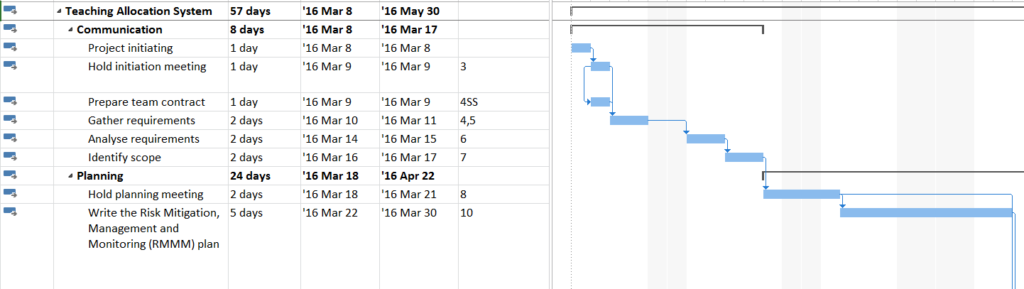

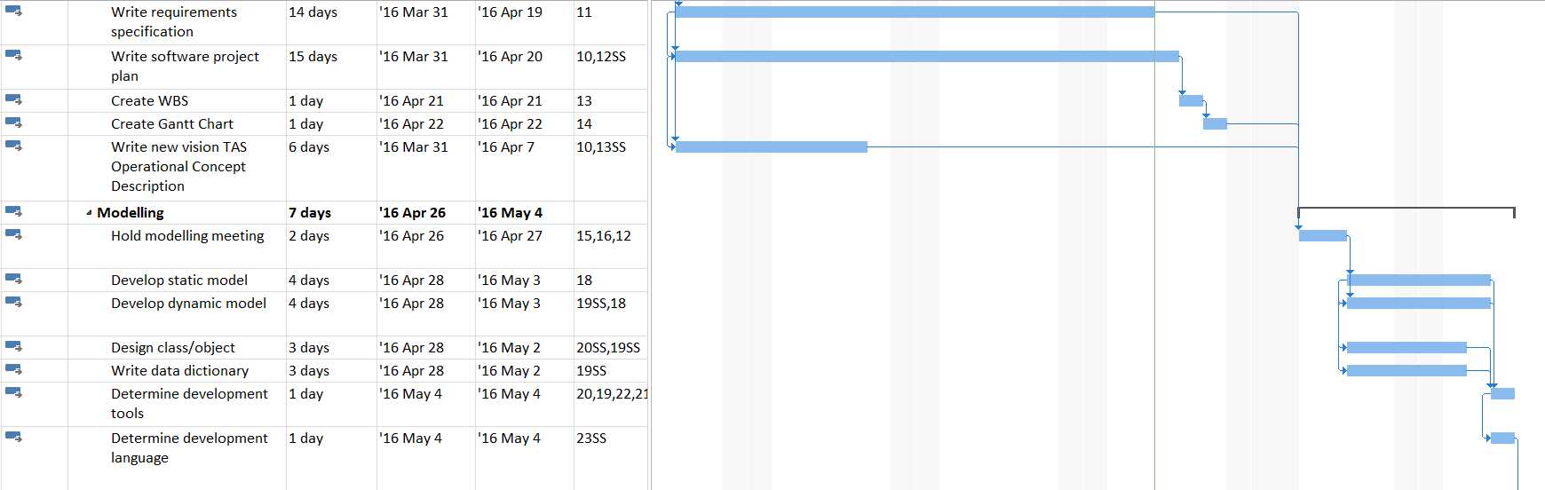

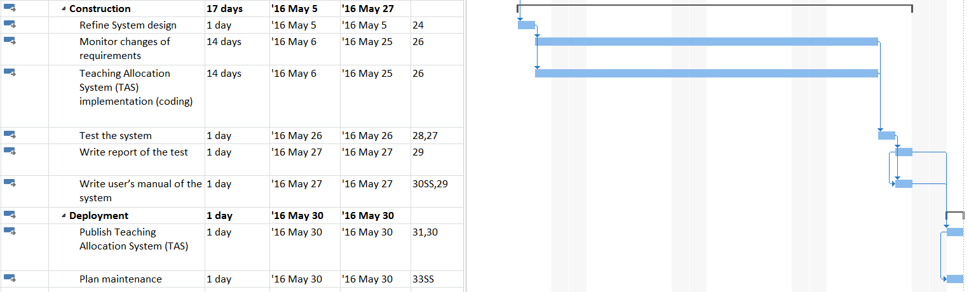

## 5.4 Minimum Time Estimated (From task graph)

* 56 working days, less than 3 months.

## 5.5 Human Resources

### 5.5.1 Team Structure

**Team Lead and Management**

* Team Leader (responsible for weekly meeting, making instructions, requirements specification, final testing, final report and deployment)

**System and User Interface Development**

* Database engineer (responsible for database system design, modelling, and implementation)
* User Interface Developer (also responsible for UI design, webpage development, and software interface)
* Internal Allocation Modules Development (responsible for the allocation functions, access rights and other administrator functions)

**Support, User Manual and Maintenance**

* Support (responsible for modelling, allocation functions, webpage templates gathering, user manual and maintenance)

### 5.5.2 Additional Member Responsibilities

* Each one should do more tasks during the development process than their main tasks.
* Project design and specification should be discussed by all the team members.
* All the members of the team should prepare development diary of the work.
* All the developers should do individual testing on their part. Tester will do the overall testing at the end of the test stage.
* Team Leader should keep the project on schedule, as well as coordinate and check every member’s work.

## 5.6 Estimate of Effort (*Person-Months*)

**LOC-Based Estimation**

|  |  |
| --- | --- |
| Function | Estimated LOC |
| Accounts database engineering | 100 |
| Units database re-engineering | 100 |
| Preference information database engineering | 200 |
| Allocation result database engineering | 100 |
| Limitation of allocation units | 300 |
| Webpage development | 600 |
| Preference selection | 1000 |
| ***Total estimated lines of codes*** | 2400 |

The estimates for LOC are plugged into the COCOMO formula for effort and duration estimation.

Effort E = a ${KLOC}^{b}$

Duration D = c $E^{d}$

The project is defined as an organic project, using default values a=2.4, b=1.05, c=2.5 and d=0.38

Effort E = 2.4(${KLOC}^{1.05}$)

= 2.4(${2.4}^{1.05}$)

= 6.02 person-months

Duration D = 0.9 $E^{0.38}$

= 2.5(${6.02}^{0.38}$)

= 1.42 months

N = E/D

= 4.24 persons

Therefore, the estimate of effort is rounded to 6 person-months.